**CS405 Machine Learning**

**Pre Lab #6 EM Report**

**Pre-Lab (25 points)**:

In this pre-lab, firstly you should use the K-means method to implement the image (Input image) segmentation



Exercise 1:

1. First, I transform the color space “RGB” to “Lab”:



Then the k-means algorithm is implemented by:

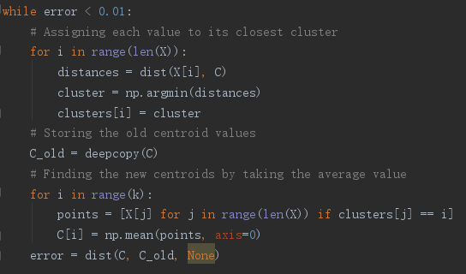

Next,I use the centroids to predict the class of each pixel in original image. The whole code is in ml_segmentation.py

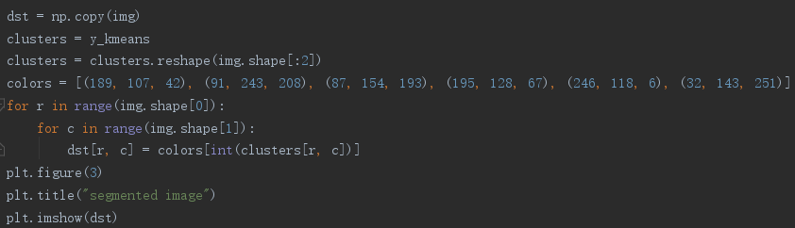

1. The clasification is represented in the below segmented image by six kind of colors.(by sklearn.cluster.KMeans, because the k-means implemented by myself has bugs)

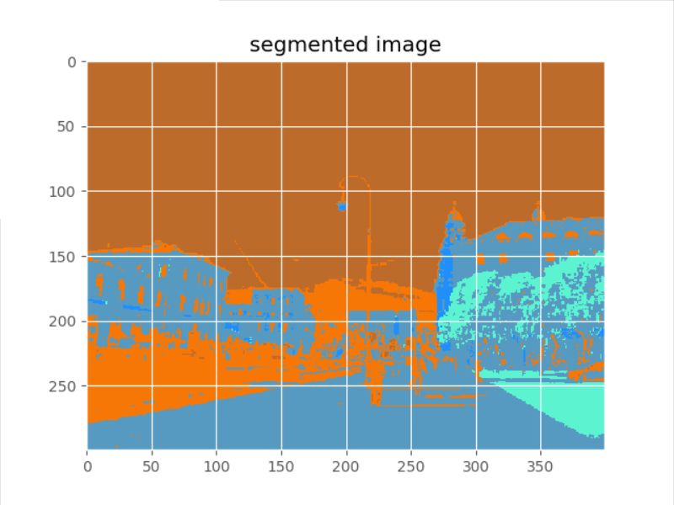

**Lab (75 points):**

Exercise 2:

Plot the original distribution:

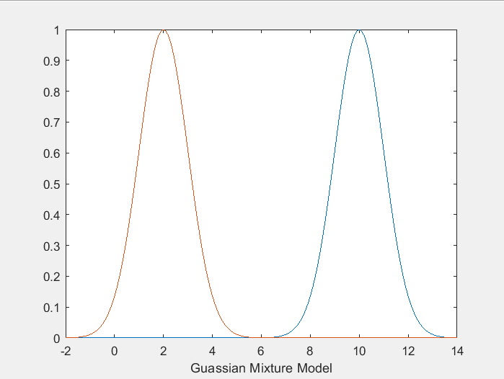

1. The data classification with EM method is by:

[mean,cov,coef,p_for_GMM] = GMM_EM(Y,2)

The implementation is given by GMM_EM.m